Chapter 16, Problem 58.

Using Fig. 16.81, design a problem to help other students better understand circuit analysis in the s-domain with circuits that have dependent sources.
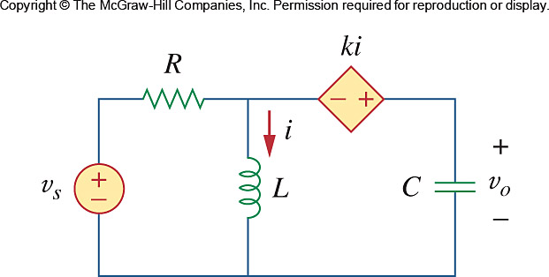

Figure 16.81
For Prob. 16.58.

